

**Blue Bike Data Analysis**

**Team Beta**

Tanisha Srivastava - srivastava.tan@northeastern.edu

Jacob Vandergriff - vandergriff.j@northeastern.edu

Abhinav Jain - jain.abhin@northeastern.edu

Hang Wu - wu.hang@northeastern.edu

Jie Deng - deng.jie1@northeastern.edu

ALY 6110 Big Data and Data Management

CRN: 70633

**Goals** **3**

**Summary** **3**

**Business Questions** **3**

**About the Dataset** **3**

**Comments: Methodology** **4**

**Data Pre-Processing** **4**

**Exploratory Data Analysis** **5**

Trend & Seasonality Analysis 5

Customer Analysis 7

Station Analysis 8

Statistical Analysis 9

**Graph Analysis** **11**

**How to Run The Analysis** **12**

Environment Dependencies: 12

Data Import 14

Statistical analysis 16

**Comments:Technical Difficulties** **16**

**Conclusions** **22**

**References** **23**

# 

# Goals

The assignment aims to analyze and derive meaningful insights from Blue Bike’s data by leveraging big data tools and solving business problems.

# Summary

Blue Bike shares bikes with the public at a minimal cost depending on the trip durations. It was established in June 2011 in Boston and has grown exceptionally since then. The blue bike system is simple, a person picks up the bike from the dock station, rides the bike for a specific time, and then returns the bike to any dock station available in the city. Our team aims to gain meaningful insights from the data by using big data tools and solving business problems.

While handling the data set is difficult to handle 9 million rows in excel, so our team decided to upload the data on AWS S3. We build the API to pull the data from S3. We imported the data from S3, and during the preprocessing, we found Null values in birthyear, user type, gender, postal code, and age.

Birth year, gender, and postal code were missing during preprocessing; however, we decided to drop this information to improve our visualization's effectiveness. In addition, we split the start and stop times and dates to create a graph showing the data and comparing the journey with trip duration.

On the other hand, we identified outliers during the data preprocessing. We determined that if we removed those numbers, our analysis would be affected, indicating the less-used blue bike station.

# Business Questions

1. What age groups are using the Blue Bike service?
2. How are the stations distributed in the city?
3. Are there stations that are anomalous, given their connections?
4. What are the most connected stations?

# About the Dataset

The data is from an AWS S3 instance

The data ranges from Jan 2019 to Sept 2022

The dataset contains more than 9 million trips in Boston.

The variables of the trip are as follows:

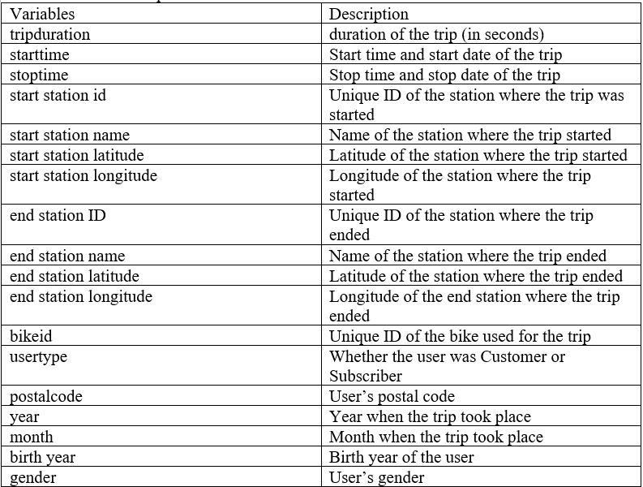

# Data Pre-Processing

There are missing values in birth year, gender, and postal code. The missing values will not be dropped due to their use in helping understand the users. 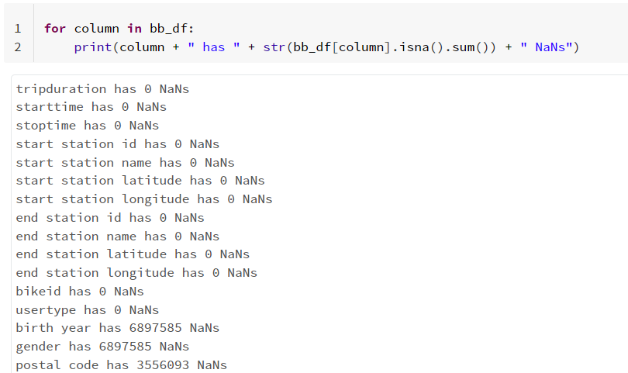

The data is added into a graph frame for a more complex network analysis. The graph is undirected as we are not concerned with the direction of the trips in this analysis.

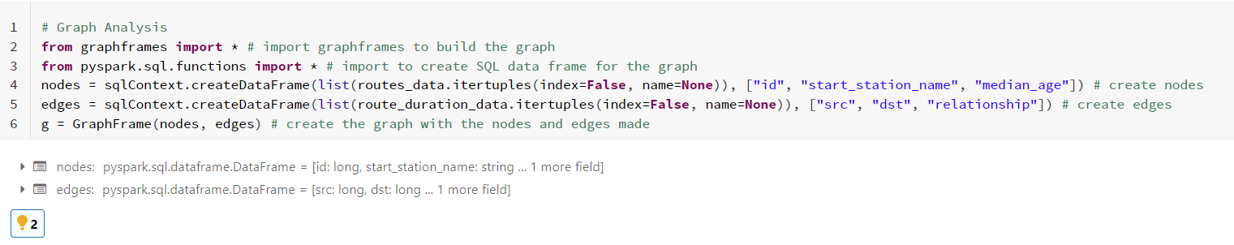

# Exploratory Data Analysis

The EDA of this data set focuses on trips and customers by considering the seasonality and trends of the trips. We break down customer attributes to better understand who is using the service. We also analyze the most connected stations.

## Statistical Analysis

**Missing No. diagram**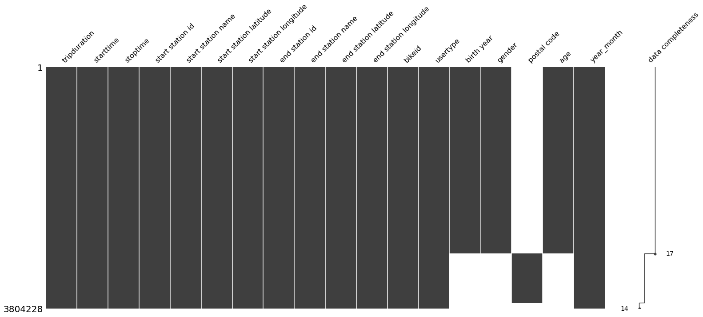

No duplicated or redundant records are found. The data is pretty clean and organized. Since we don’t have unstructured data, and the data is relatively clean, we don’t have to tokenize and thus correlate unstructured data to structured ones.

Data Distribution Diagram for the BlueBike Data

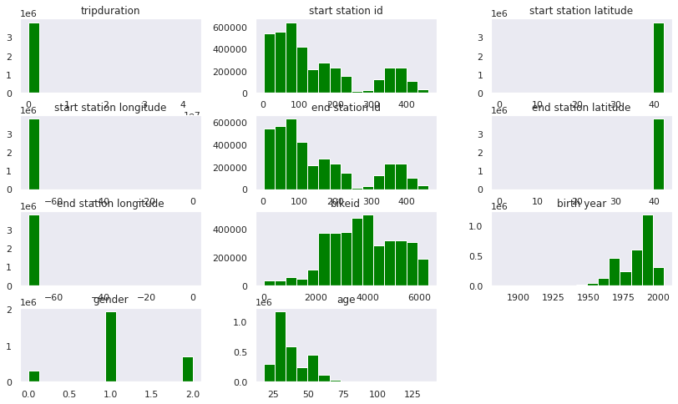

Correlation Diagram

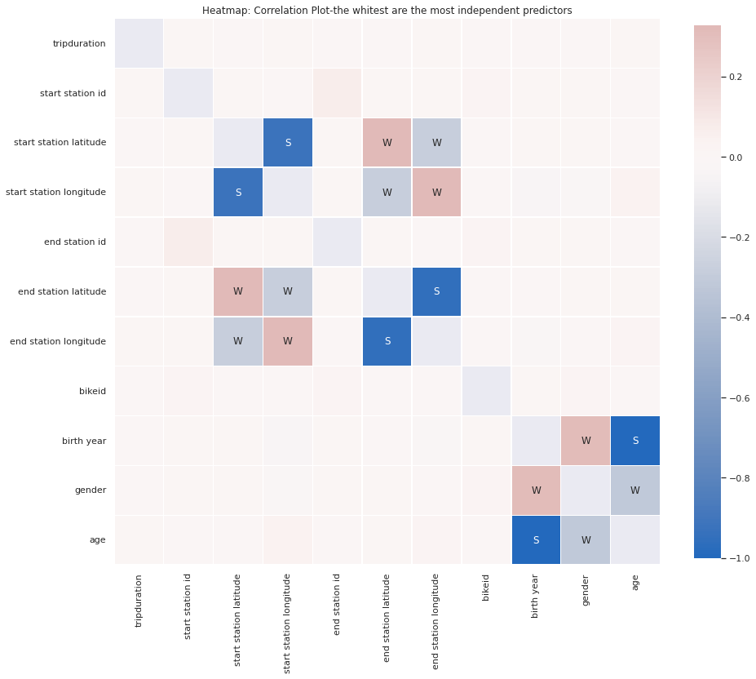

Skewness and Kurtosis analysis for the Blubike dataset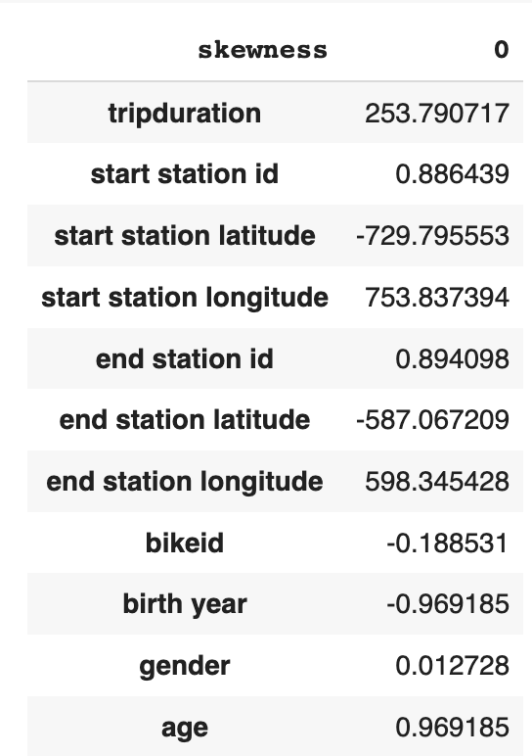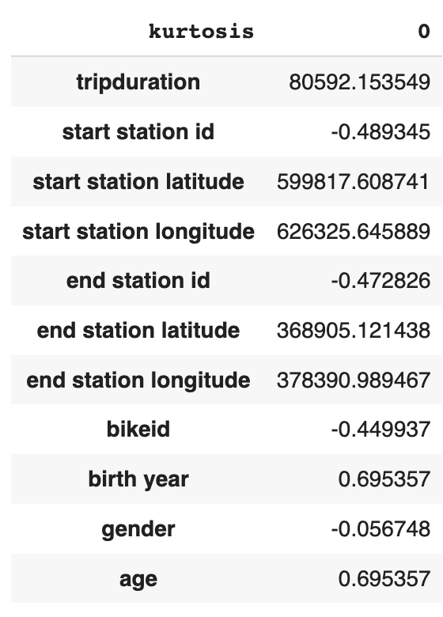

The trip duration skewed to the right significantly and has a much higher kurotisis than what’s being allowed (kurtosis < 3), this indicates that multiple outliers can be spotted. Mean/Median analysis only works with start and end longitude, whereas the latitude also shows many outliers.

## Trend & Seasonality Analysis

Over time, the number of trips has increased. There is clear seasonality in the time series given the peaks and valleys in the visualization.

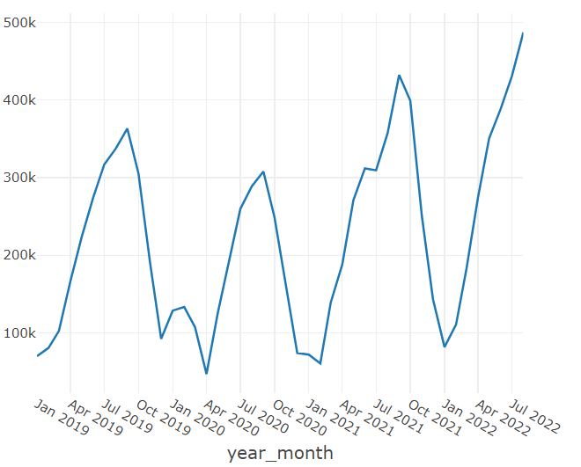 **Number of Trips Over Time**

While trip count is increasing, the median trip duration trend remains flat. There is also seasonality in this time series. Peaks occur in the summer and valleys occur in the winter months. There is a large spike in the spring of 2020. This was the beginning of the COVID-19 pandemic so we can infer people preferred Blue Bikes rather than rideshare, taxis, or public transit.

**Median Trip Duration Over Time**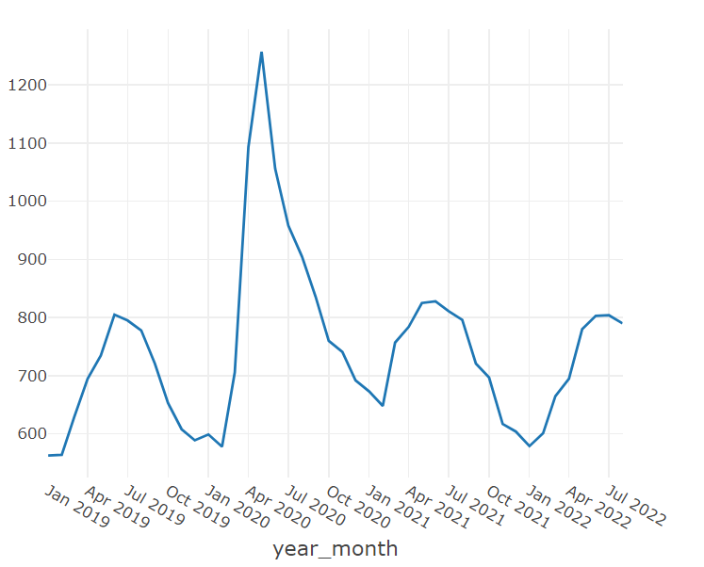

As we look at seasonality, we break down the time series by month and hour. The monthly seasonality shows a peak in early fall and lows in the winter months.

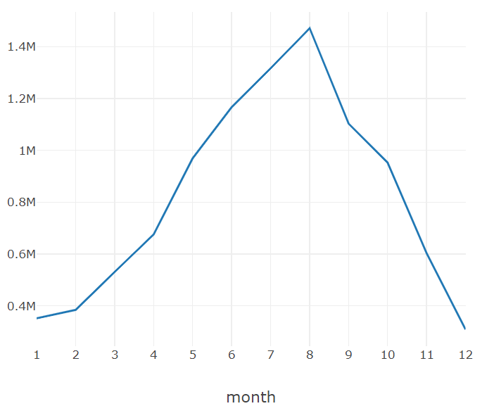**Monthly Seasonality - Number of Trips**

The hourly seasonality shows a peak around 5 pm or 17:00 and a low around 4 am or 4:00. The number of trips taken increases over the course of the day but the trip count starts to decrease sharply at 9 pm or 21:00.

**Hourly Seasonality - Number of Trips**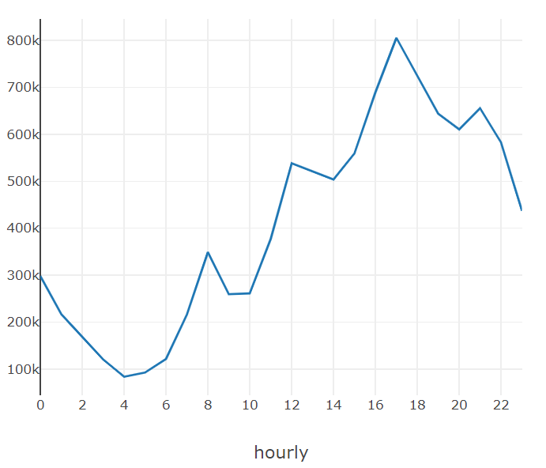

## Customer Analysis

The customer analysis uses age, user type, and gender to segment the data. There are users who have an unlisted gender and these people tend to be older. Both subscribers and customers across male and females have similar median ages in the early 30s. The variation of age measured by the standard deviation is larger for subscribers. 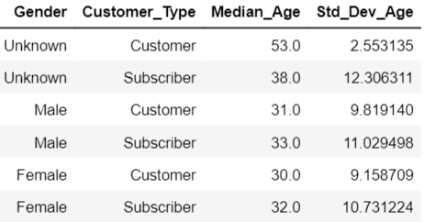

## Station Analysis

Both the top 3 start and end stations are the same. These top stations are also on Mass Ave. Stations on MIT’s campus are also widely used. In the map below we can see stations are uniformly distributed in the city of Boston.

**Top ten starting station Top ten ending station**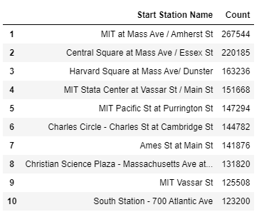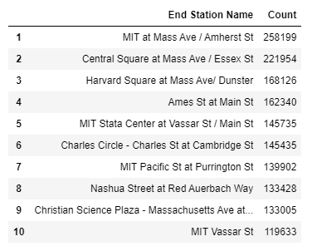

**Stations Map**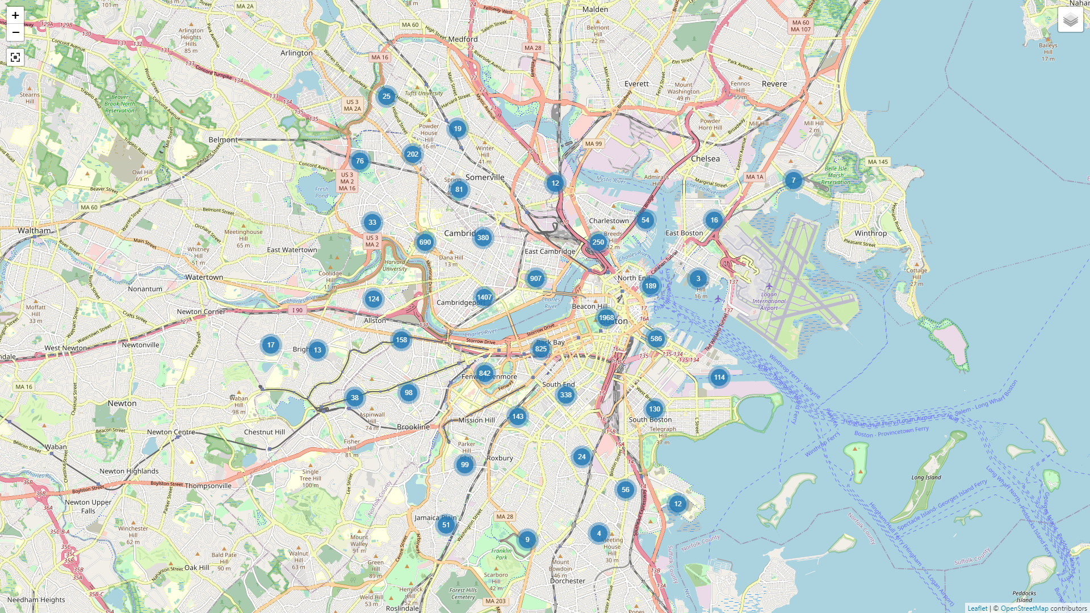

## Graph Analysis

The Blue Bikes are a network which graph frames are optimized to analyze. By using Spark’s GraphFrames package, an undirected graph can be made. In the same package is a label propagation algorithm to find communities in the graph. This will be helpful in finding unique nodes.

Using the NetworkX package, the graph can be displayed. After running the label propagation algorithm, four unique nodes were found. They are colored red in the visualization. The 3D visualization shows most of the nodes are clustered together in the network in a way that is slightly less chaotic.

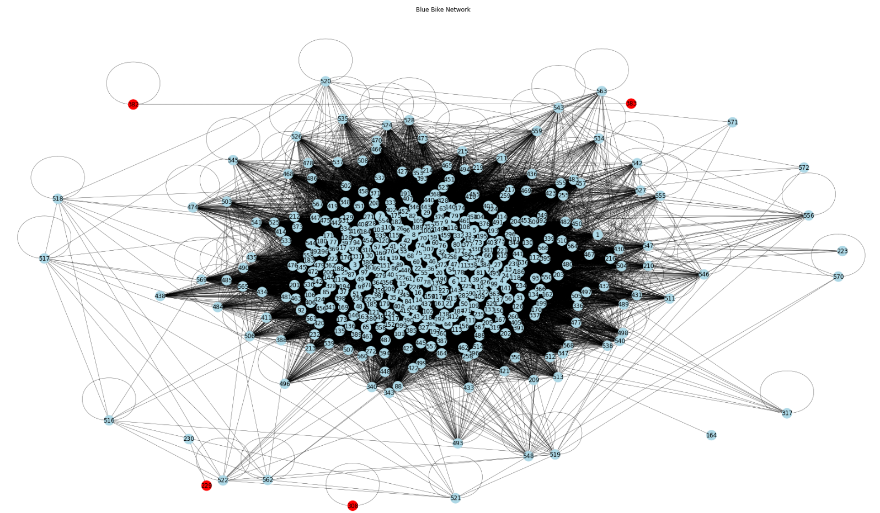

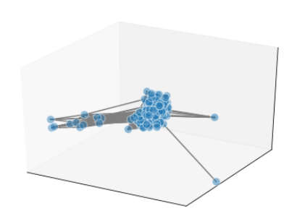

**3D Model of BB Network**

The nodes found in the label propagation process are stations BCBS Hingham, 8D QC Station 01, MTL-EC04-01, and MTL-EC05.1-01. The BCBS Hingman station is only connected to itself while nodes typically have many connections. Stations MTL-EC04-01, and MTL-EC05.1-01 are connected to each other and only have one trip. These nodes either no longer exist or are of just poor quality. Station 8D QC Station 01 has only one connection which we already know to be unusual. This analytical task can find nodes that are either of poor data quality or under utilized.

# How to Run The Analysis

## Environment Dependencies:

Prior to running the analysis, the GraphFrames library must be installed. To download the library, visit this link:

<https://spark-packages.org/package/graphframes/graphframes>

To choose the correct jar file, you must match the Spark and Scala versions to your cluster.

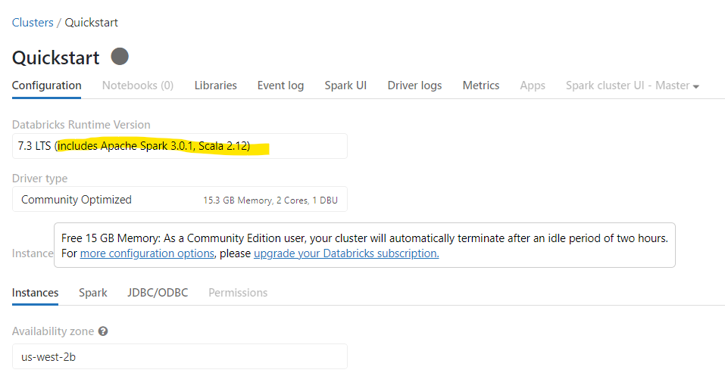

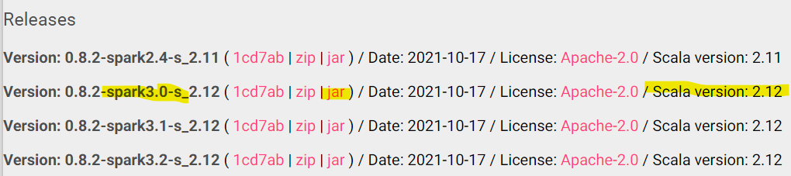

By matching the versions, the correct library for your cluster will be installed. If you do not match the versions, the cluster will fail to run the complete GraphFrames library.

After downloading the jar file, do to Workspace -> User -> Create -> Library -> Drop Jar File

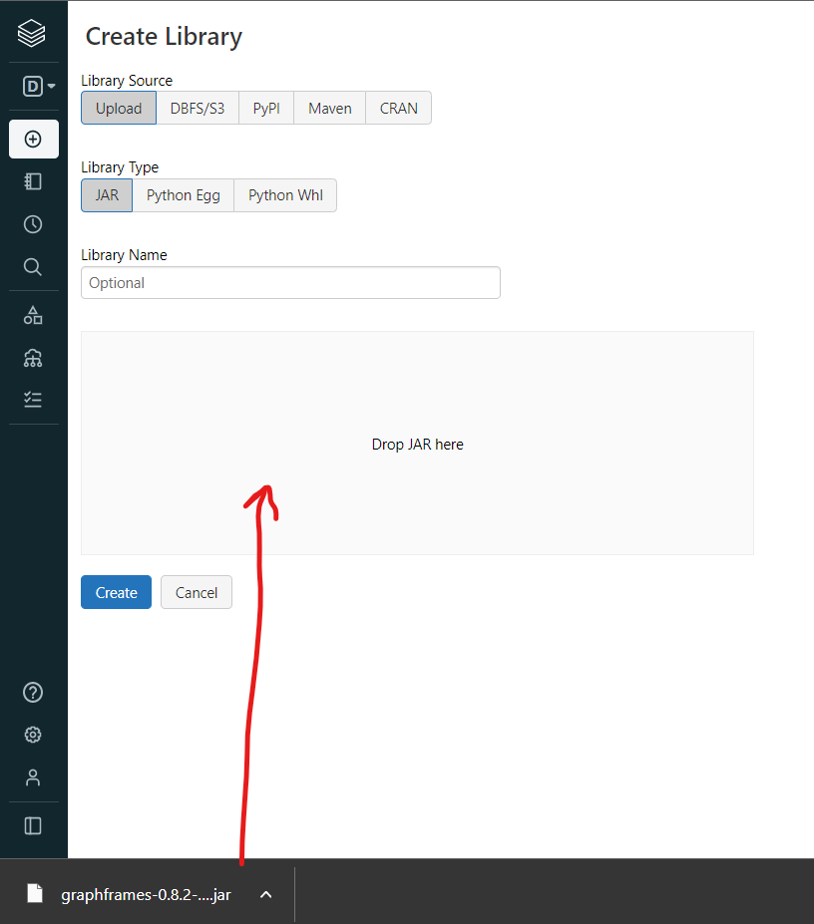

Be sure to have the same Library Source and Type selected as we do above.

Click create and then click install on all clusters.

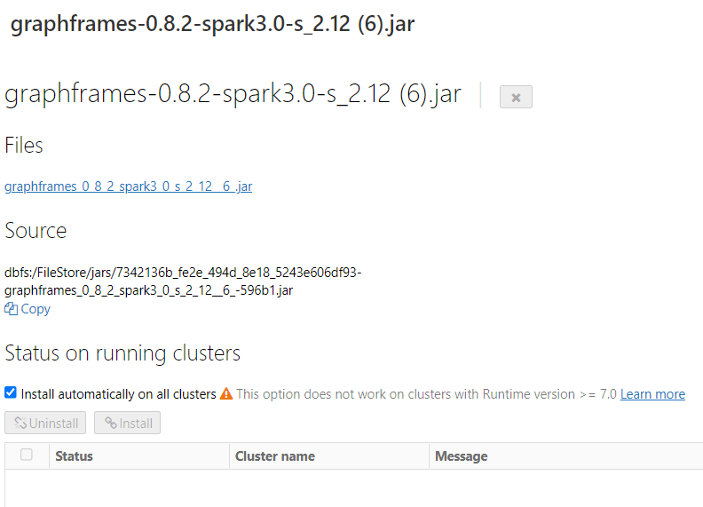

You are ready to run the code. Please return to the notebook file.

**Notebook Walkthrough:**

In this section, you will learn how to run our analysis. Please follow step by step to ensure success.

**Pip Installations and Package Imports**

Below you will see the needed packages not loaded into Databricks.

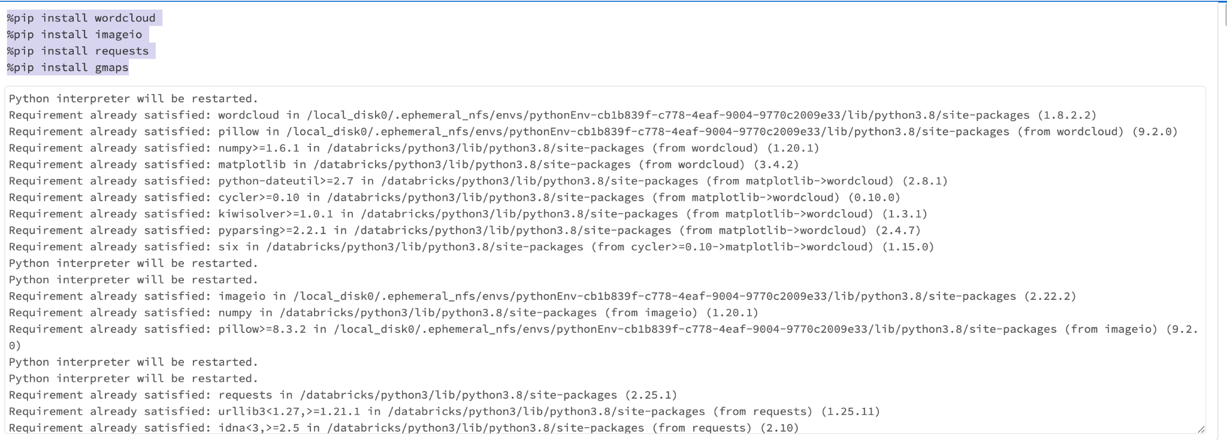

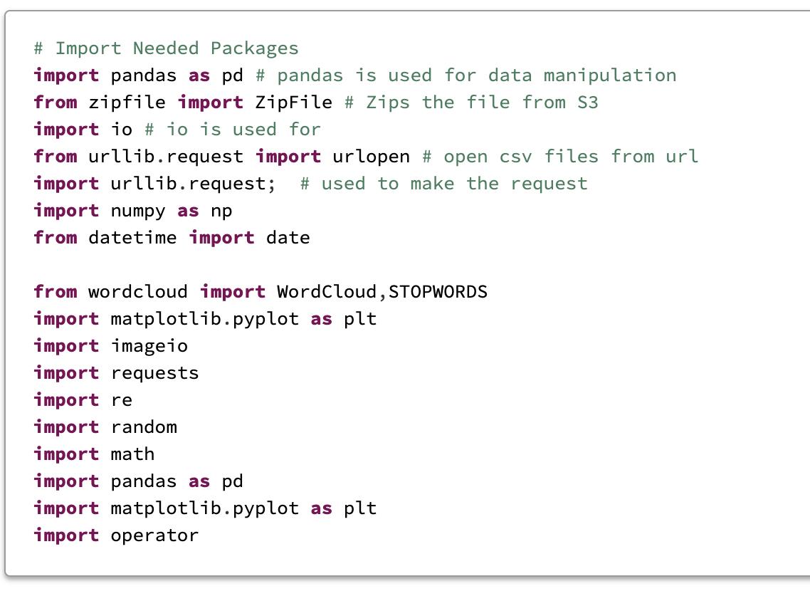

## Data Import

Use the below function to pull the data into the notebook. This function will call the S3 instance and will retrieve the Blue Bike data from Jan 2019 to Sept 2022. These dates are references in the function parameters in YYYYMM format.

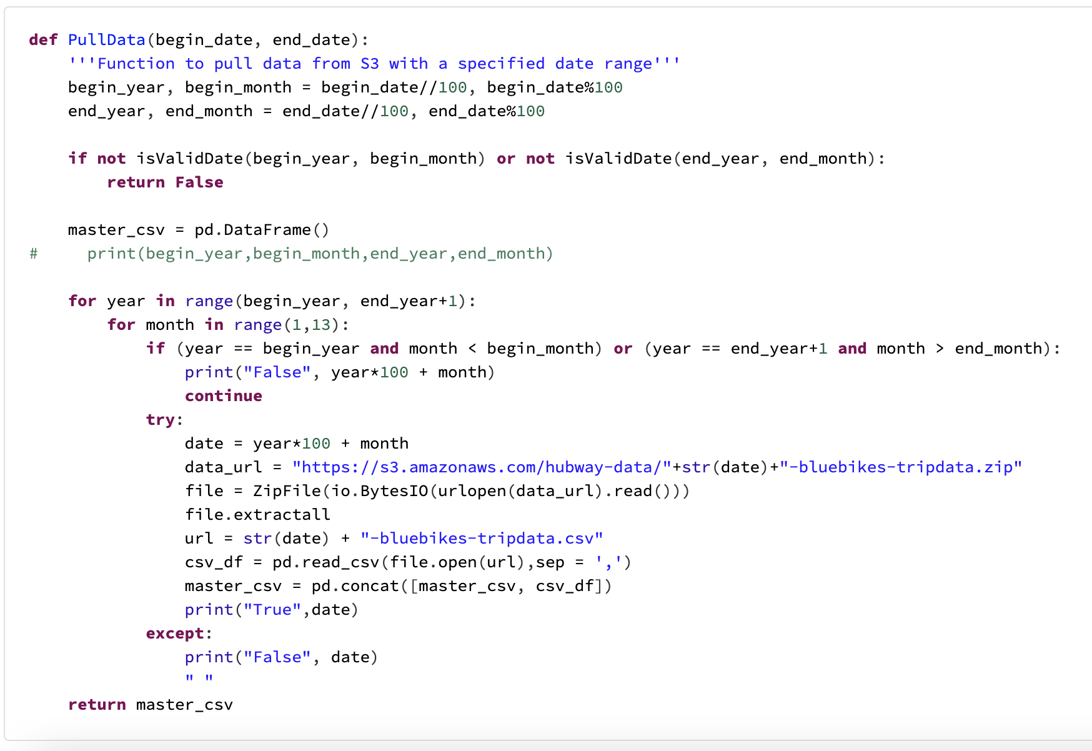

**Data Exploration**

The lines below will show the number of rows in the data set and the number NaN values. Each column is looped and the count of NaNs are printed.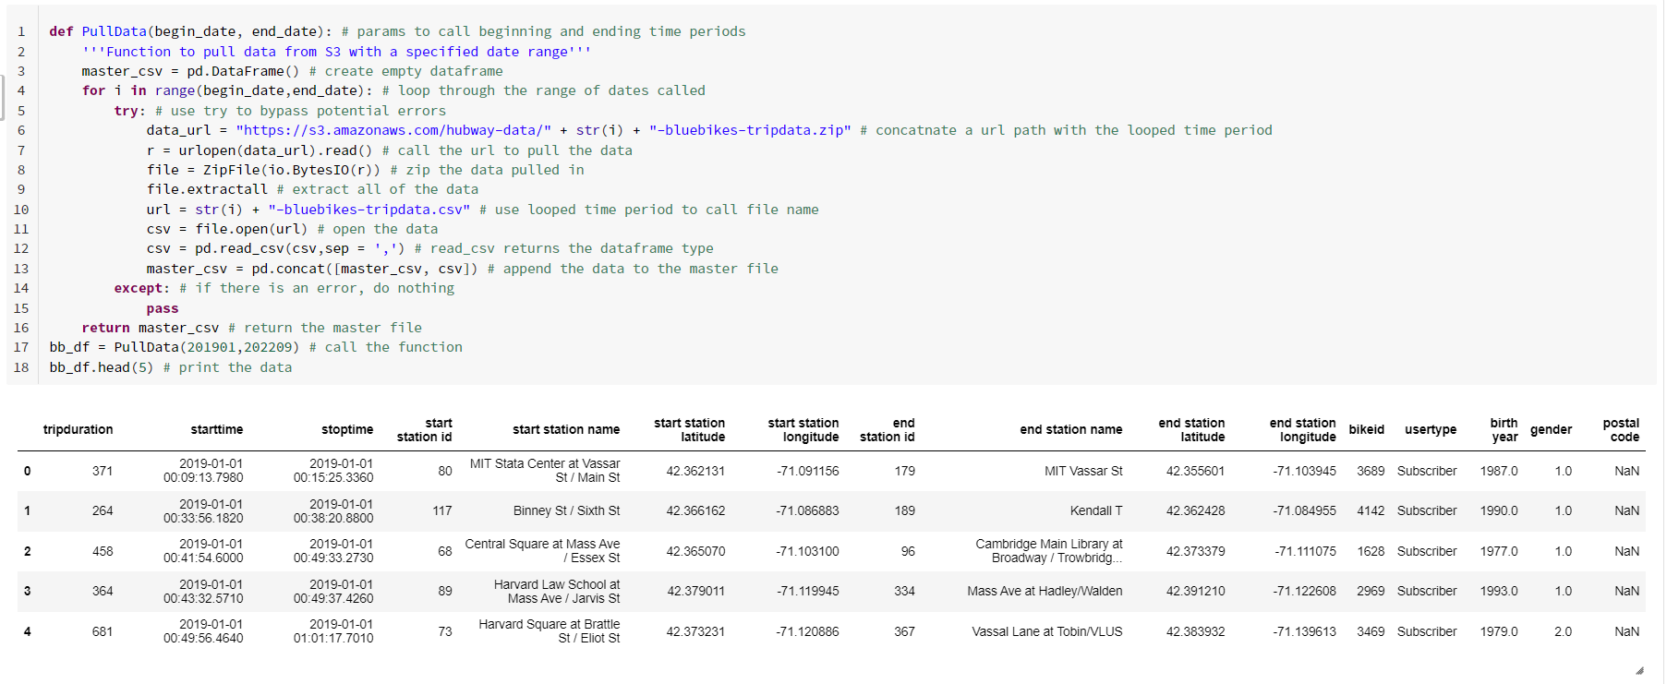

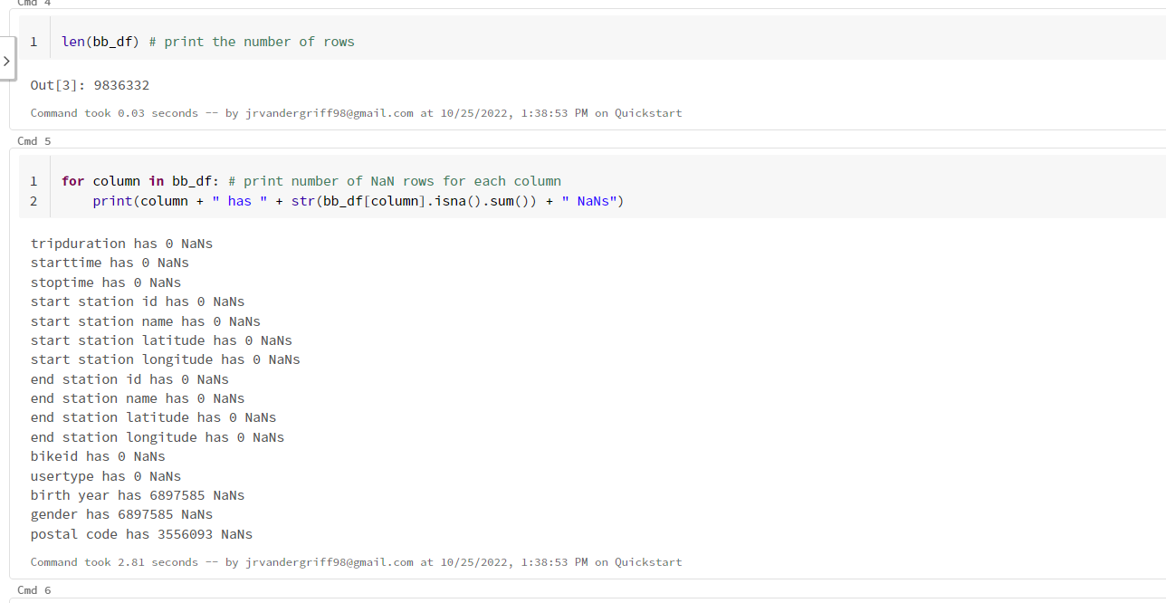

## Statistical analysis

Both numerical distribution and correlation code can be seen below:

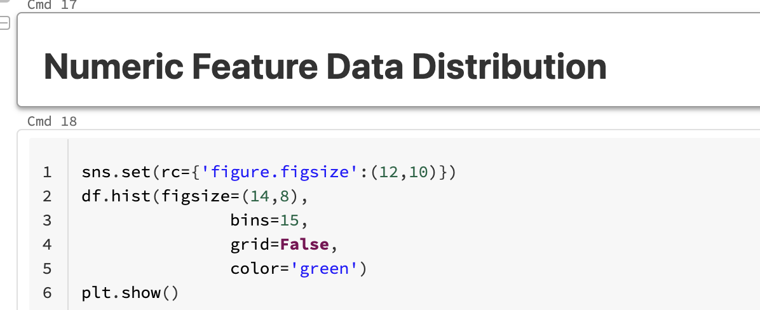

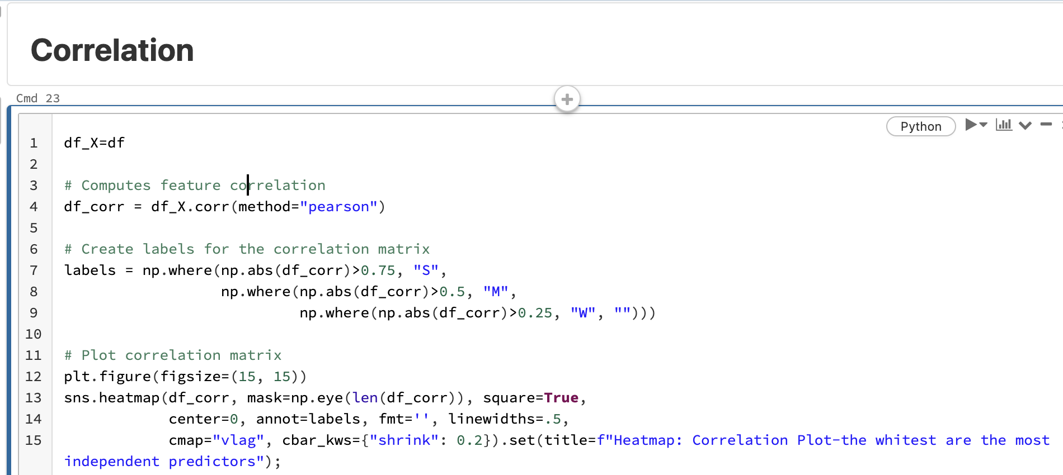

# Comments:Technical Difficulties

**Technical difficulties regarding to the folium library and Google Map**

The folium library is used to build the circle graph of every coordinates in the map.

Create API keys since we are using gmaps/google maps instead of folium, however due to memory issues, it's likely that a bigger computation power is needed for drawing 3 million circle markers on a map.

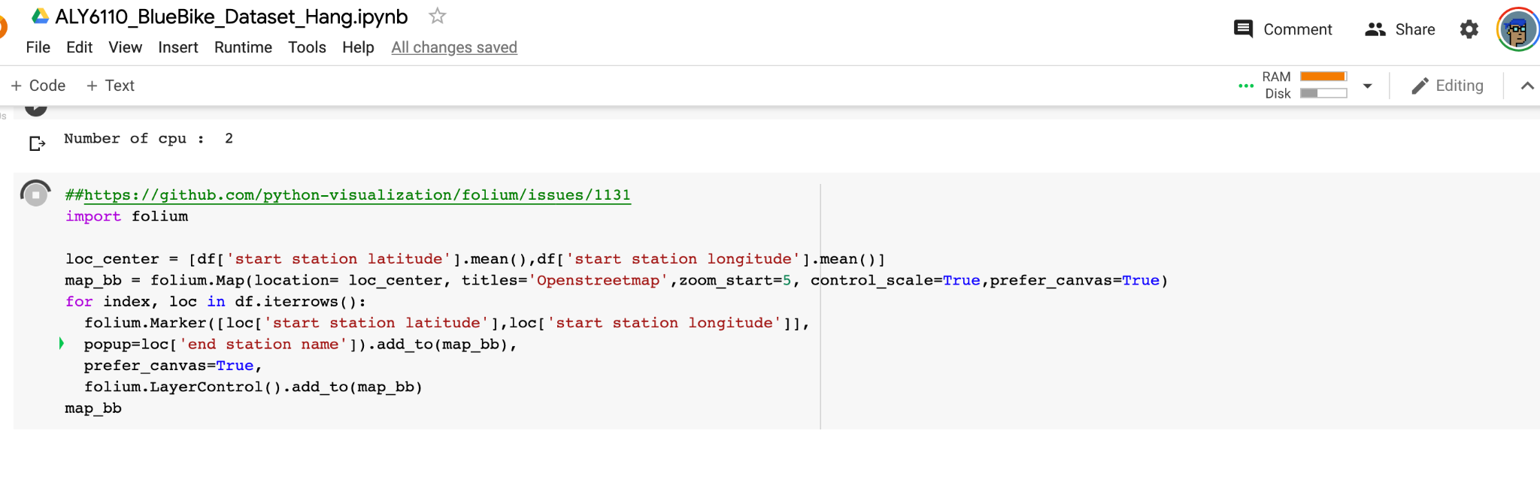

The gmap/google map has also been checked both on Google Colab(a big data platform hosted by Google for Python) and Databrick. Memory leak issues such as below is displayed.

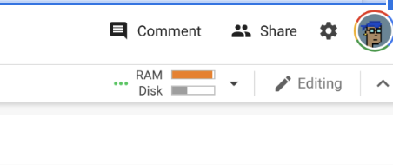

Said technical difficulties can be resolved by using different or bigger cluster to compute, or utilizing elastic computation to add rams automatically while executing the code.

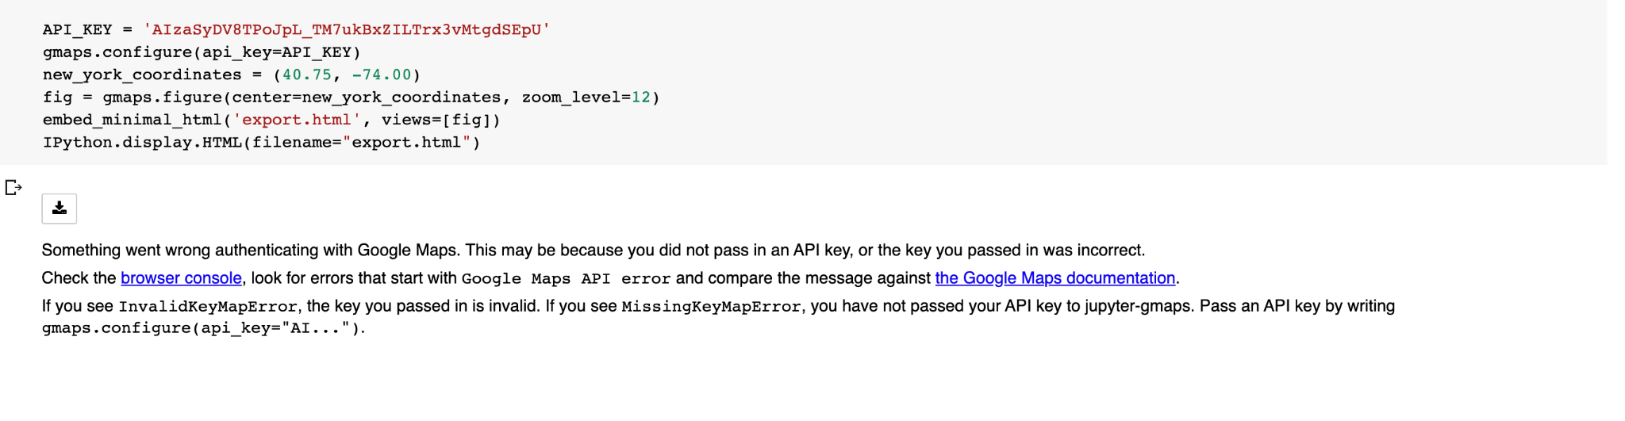

In order to build Google map such as below, the API key has to be created then the code can authenticate the key with Google Map before launching the map such as figure above.

**Graph Analysis**

The Blue Bikes are a network so a network analysis is appropriate. A graph frame is the best choice when performing a network analysis.

Before building the graph, the data needs to be transformed in a format to feed the nodes and edges. The code below creates two data frames: routes_data and route_duration_data. The routes_data frame pulls the start stations with the median age as metadata and removes any duplicates. These will be the nodes. The route_duration_data pulls the start and end station with the median trip duration between them. This data frame is the edges.

This graph uses the stations and nodes with the median age as the metadata and the edges are the median trip duration between nodes. The median trip duration defines the relationships between the nodes as this is an important frame for the analysis. Number of trips could have been chosen as well.

The next bit of code uses the aforementioned data frames to build the nodes and edges with GraphFrames and sqlContext.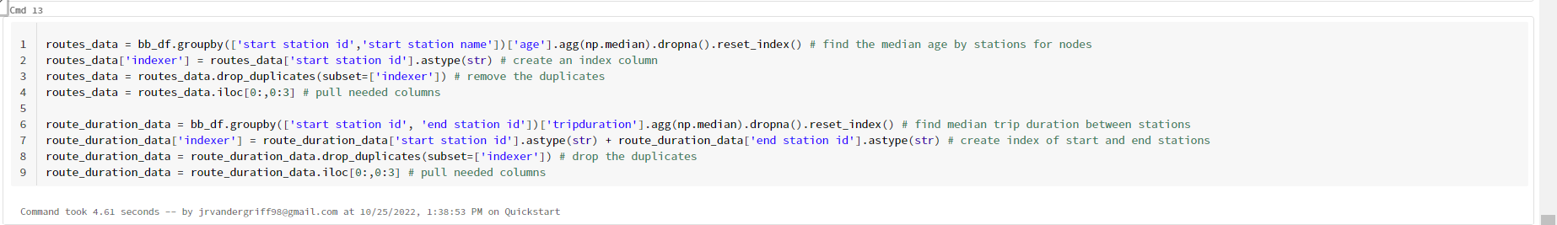

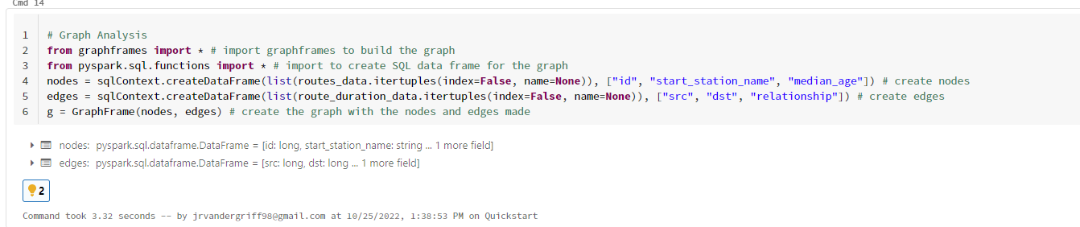

Now that the graph is built, a label propagation analysis can be run to find communities in the graph or unique stations. The algorithm will iterate a maximum of ten times. This will label the nodes and group them into communities.

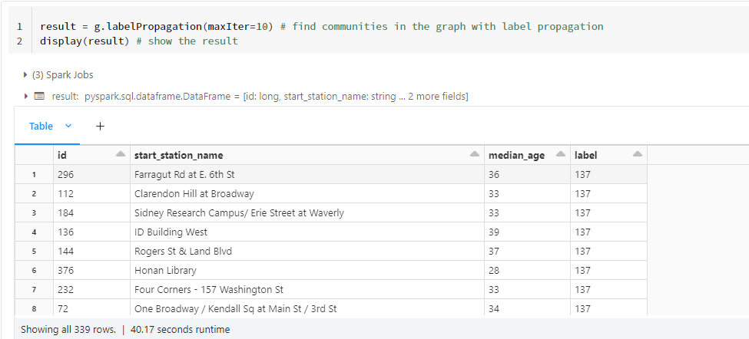

The next lines of code will summarize the communities by node count. The 308, 229, and 382 labels seem to be anomalous and the results are queried by each of those label to see the metadata and station name

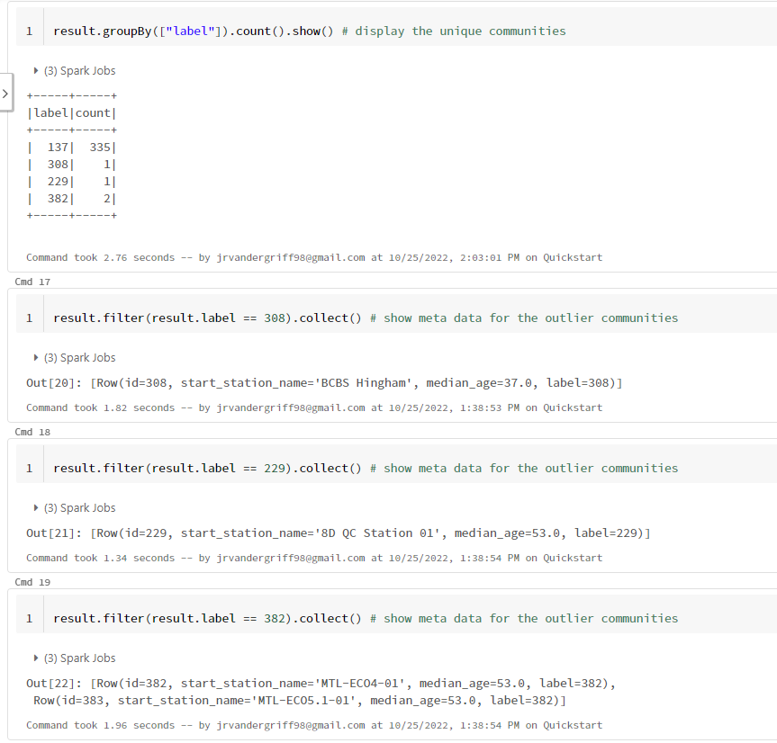

The next lines of code will show the trips data of the unique nodes for further inspection.

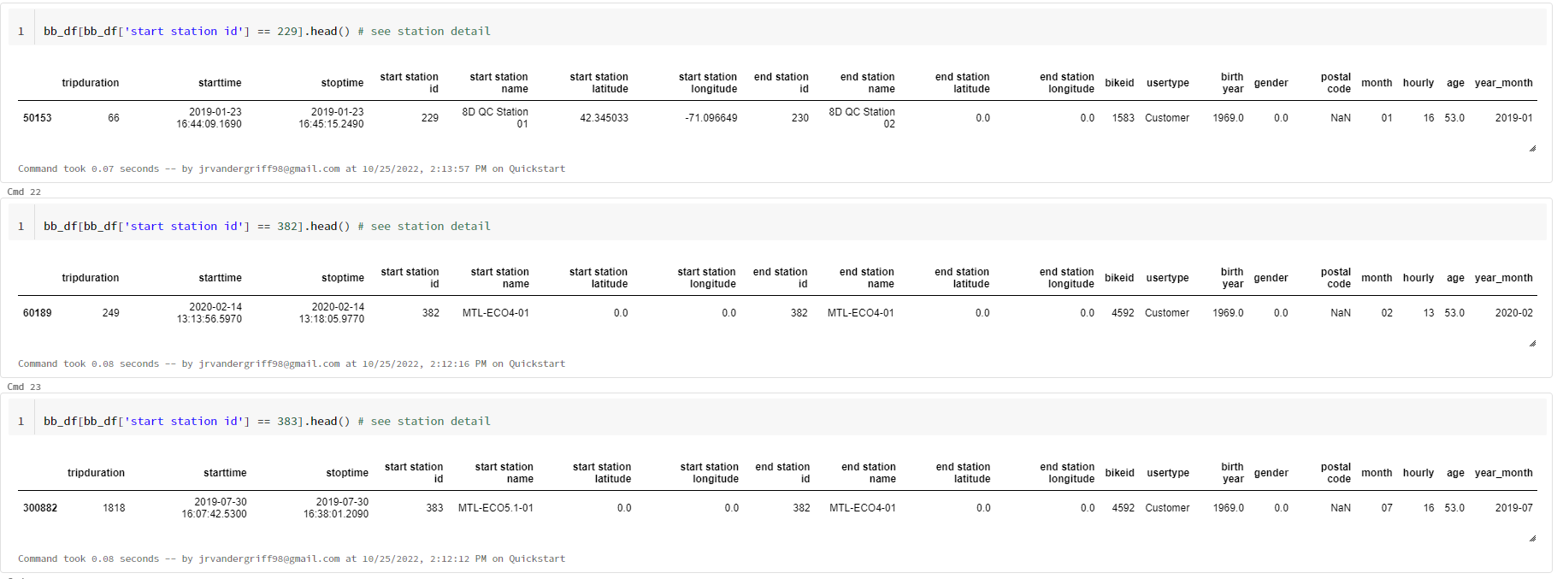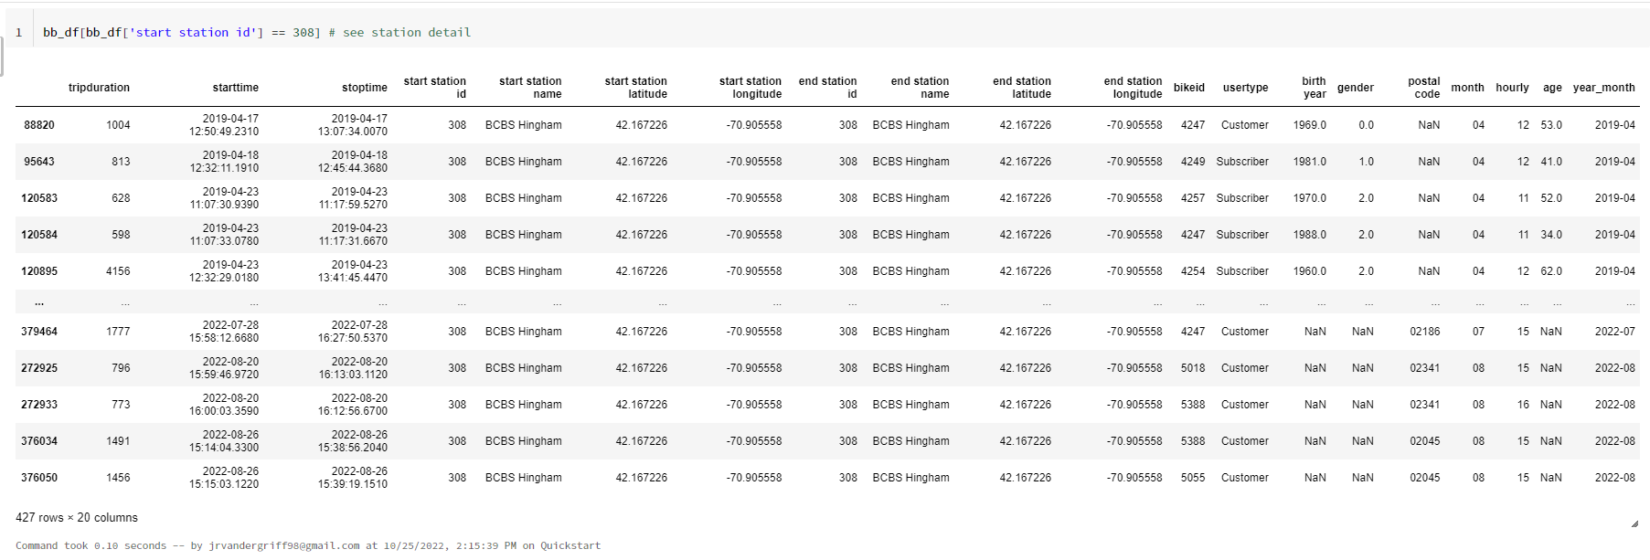

Next we use the NetworkX package to plot the graph and color code the unique communities to see how they fit in the network.

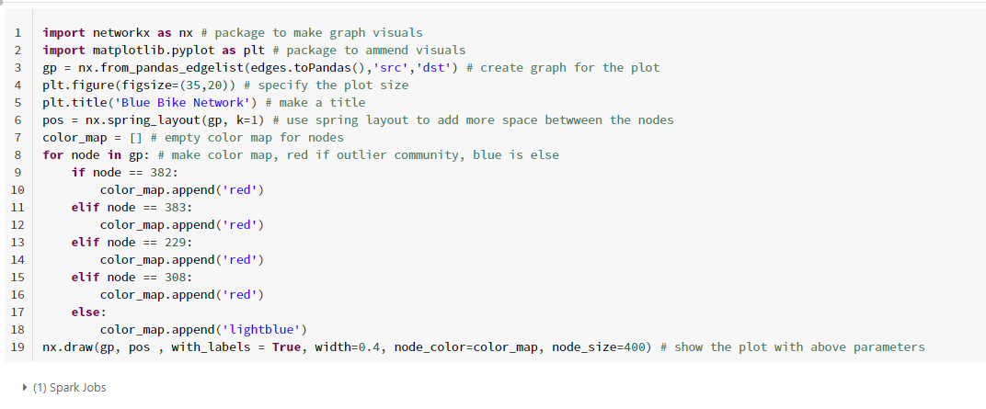

The following visualization will appear. The location of the nodes may change slightly but the graph is still the same.



This visualization is overwhelming but we can see the uniqueness of the outlier nodes. They do not behave like the other nodes.

The next code will yield a 3D plot of the graph to see it in another way. Notice the majority of the mass of the graph is still clustered around a central point. 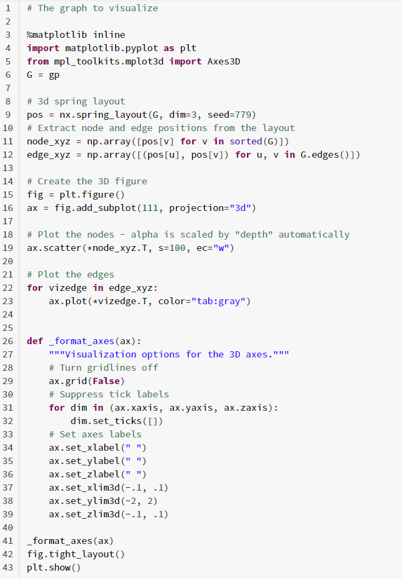

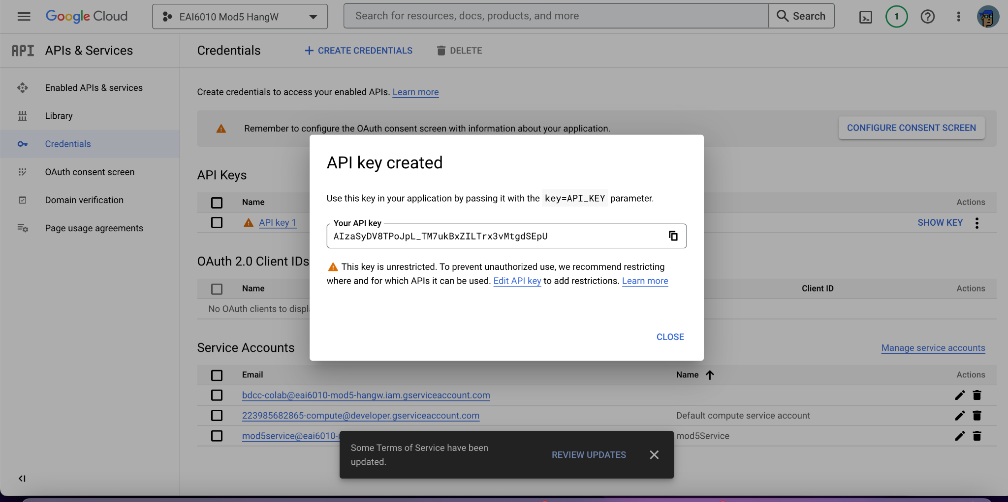

# Q&A

The answers to the business questions are as follows:

1. **What age groups are using the Blue Bike Service?**
   1. Younger adults in their early 30s.
2. **How are stations distributed in the city?**
   1. Stations are uniformly distributed.
3. **Are there stations that can be considered anomalous given their connections?**
   1. Stations that have bad data quality or are solely used are considered anomalous.
4. **What are the most connected stations?**
   1. Stations on Mass Ave are the most connected stations.

# Conclusions

In this report we explore the statistical and graphical analysis of the Blue Bike program in Boston, MA. 9 million raw data have been analysed. Graphical analysis is proven to be a valid tool for route analysis while the map is great for displaying said routes and endpoints. Most of the technical difficulties revolved around libraries import and graph display, this comes down to RAM and CPU issues of the Cloud Clusters each of our members use. Jar importation is needed to build a custom library for Databrick because the community version doesn't support the graphframes library. From the above analysis, we derived interesting highlights. The number of users significantly decreases in the month of November and December, due to the winter season it’s hard to ride a bike in the snow. The number of users start increasing in February and reached a peak in August with more than 1 million users. Most of the customers are in their early 30s, we have more variation in the Subscribers. The top stations are MIT at Mass Ave., Central Sq at Mass Ave., and Harvard Sq. at Mass Ave. We have one unique station, BCBS Hingham. This station is unique, as the last ride was in August 2022, suggesting the station is not being used. Most of the station uses are centralized in the city.

# References

1. Chen, D. (2021, July 15). *Label propagation algorithm and its Application*. Medium. Retrieved October 20, 2022, from https://medium.com/@dezhouc2/label-propagation-algorithm-and-its-application-162d03f10d3a
2. *Graphframes - Spark Packages*. (n.d.). Retrieved October 20, 2022, from https://spark-packages.org/package/graphframes/graphframes
3. Motivate International, I. (n.d.). *Bluebikes System Data*. Blue Bikes Boston. Retrieved October 20, 2022, from https://www.bluebikes.com/system-data
4. OpenKB. (1970, January 1). *Understanding PageRank algorithm in Scala on spark*. Open Knowledge Base. Retrieved October 20, 2022, from http://www.openkb.info/2016/03/understanding-pagerank-algorithm-in.html
5. *Software for complex networks#*. Software for Complex Networks - NetworkX 3.0b2.dev0 documentation. (n.d.). Retrieved October 20, 2022, from https://networkx.org/documentation/latest/index.html
6. *Spark SQL, DataFrames and datasets guide*. Spark SQL and DataFrames - Spark 2.3.1 Documentation. (n.d.). Retrieved October 20, 2022, from https://spark.apache.org/docs/2.3.1/sql-programming-guide.html
7. *Visualizations*. Visualizations | Databricks on AWS. (n.d.). Retrieved October 20, 2022, from https://docs.databricks.com/notebooks/visualizations/index.html